Second Grade Supply List (School)

Bring the following items on the first day of school.

Please label the following items with your child’s first AND last name. These items will stay in your child’s desk throughout the year.

- 8 MEAD Composition books
(Writing, Reading (2), Math, Science, Homework, Foreign Language, Social Studies)
- One 1.5-inch binder
- A set of 12 dividers
- 9 STURDY PLASTIC folders:
Two (2) green
1 red
1 orange
1 purple
1 blue: 1 White
1 yellow:
1 Black:
- 1 clipboard 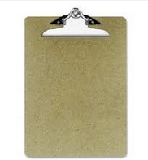
- 10 clear sheet protectors 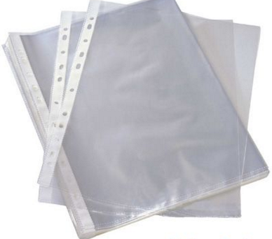
- 3 boxes of No. 2 pencils
- 2 large erasers
- 1 pack of dry erase markers (a variety of colors)
- 1 dry erase eraser
- 1 pack (24) of Crayola Crayons
- 1 pack of Crayola markers
- 1 pack of Crayola colored pencils
- 1 Highlighter (any light color)
- 1 pack of post-its (any color)
- 5 packs of Index cards
- 1 headphone

Bring the following items on the second day of school.
The following items will be collected and will be distributed to the class as needed.
DO NOT put your child’s name on these items.

- 1 pair of scissors
- 1 box of baby wipes (i.e. Pampers)
- 1 roll of scotch tape
- 4 Elmer’s glue sticks (large)
- 2 Liquid glue
- 2 rolls of paper towels
- 2 bottles of hand sanitizers
- 2 bottles of hand soaps
- 2 large boxes of tissue
- 2 boxes of gallon sized Ziploc baggies - (NO Zipper Baggies)
- 2 boxes of sandwich sized Ziploc baggies

*Please note that all of the items listed above will stay at school throughout the year.

二年級 -- 学习用品清单

請在开学第一天把下列學習用品带来.
請在下列學習用品上寫上孩子的全名。這些學習用品將留在孩子的書桌裡。

- 8本MEAD 的寫作簿（写作, 阅读（2）数学，科学，生词, 社会学, 作业, 外语)
- 1个1.5吋厚的文件夹和12张分页纸
- 9个坚硬的塑料文件夾(每个颜色一个：红色，蓝色，黄色，橙色，紫色， 白色，黑色；两个绿色，）

- 1個剪貼板
- 一袋10张透明保护膜
- 3 盒2号铅笔
- 2块橡皮
- 1包彩色白板笔和1个板擦
- 1个削铅笔刀
- 1盒Crayola水彩笔
- 1盒24色Crayola蜡笔
- 1盒Crayola彩色铅笔
- 1支高光笔（任意颜色）
- 1板便利贴纸（任意颜色）
- 5包Index 卡
- 一副耳机

請在第二天把下列學習用品带来.

下列用品将在课堂上用。不需要把你的孩子的名字寫在這些用品上。
- 1把剪刀
- 1卷透明胶带
- 4支Elmer的膠水和2瓶瓶装胶水
- 1 盒 baby wipes (i.e. Pampers)
- 2捲厨房紙
- 2瓶消毒擦手液
- 2盒的面纸巾
- 2盒（gallon 大小的） "塑膠袋"
- 2盒（sandwich 大小的） "塑膠拉鍊袋"
- 2瓶洗手液
*請注意，所有上列的用品全年都会留在學校供给学生使用。你必須有自己的一套用品供学生在家做功課使用。

