Dear Parents,
Please purchase the following supplies and send them into school on the first day of school. Please clearly label the supplies with your child’s first/last name and class. Please purchase only the indicated quantity.
Fifth Grade Supplies (School): 以下是五年级需要的用品 (在学校的):
- 8 plastic folders with pockets: (solid colors only-no designs or characters) 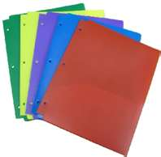(1 green, 1 red, 1 blue, 1 orange, 1 yellow, 1 white, 1 black, 1 purple)
8个塑料并带有两边口袋的文件夹 (绿色，红色，蓝色, 橙色, 黄色, 白色, 黑色, 紫色)
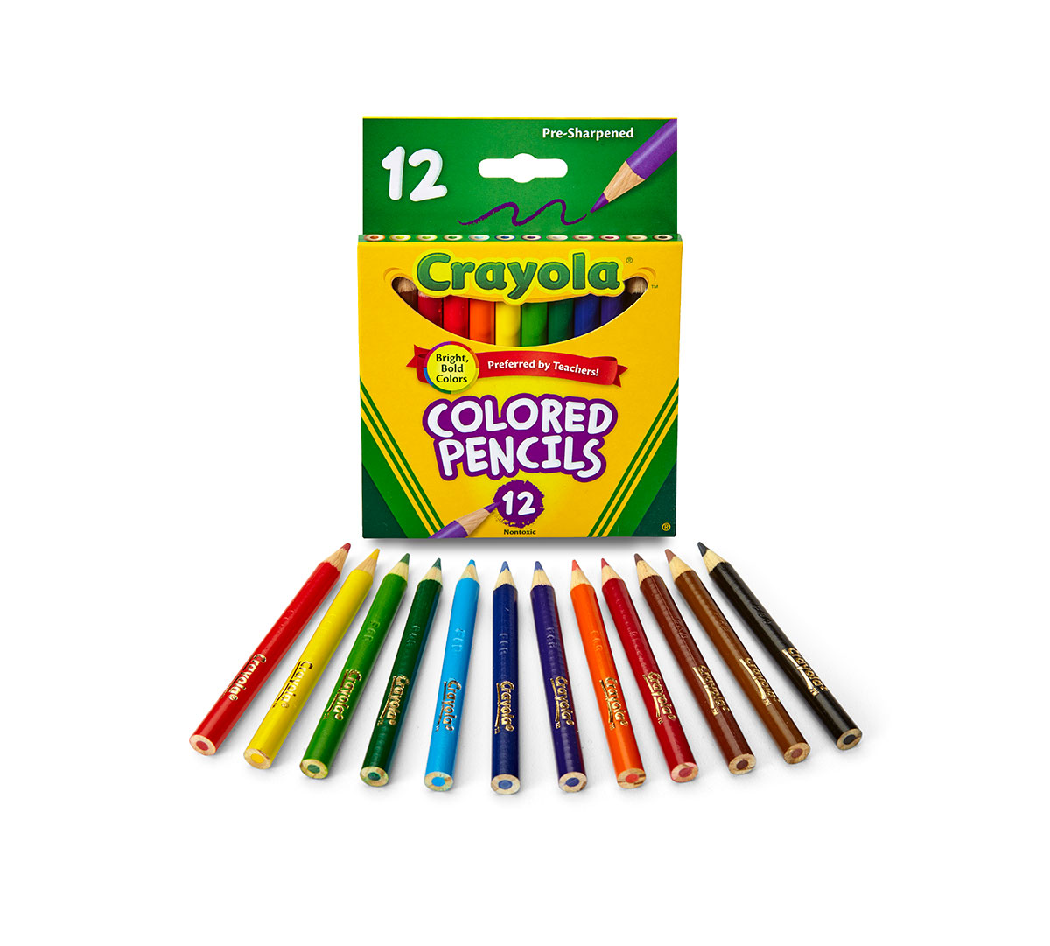
- 7 Marble Notebooks (no spiral, one subject 70 pg.) 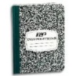 七本笔记本 (不要卷轴, 大约70页)
- 1 box of colored pencils 彩色铅笔一盒
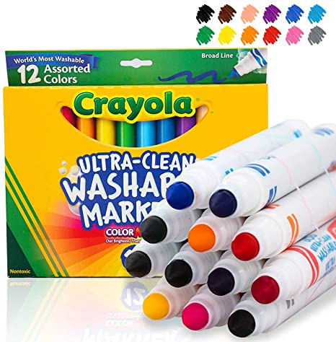
- 1 box of washable markers 水彩笔一盒
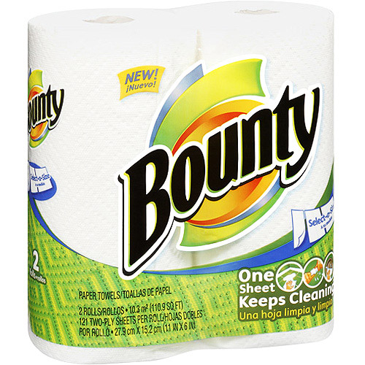
- 2 rolls of paper towels 纸巾两卷
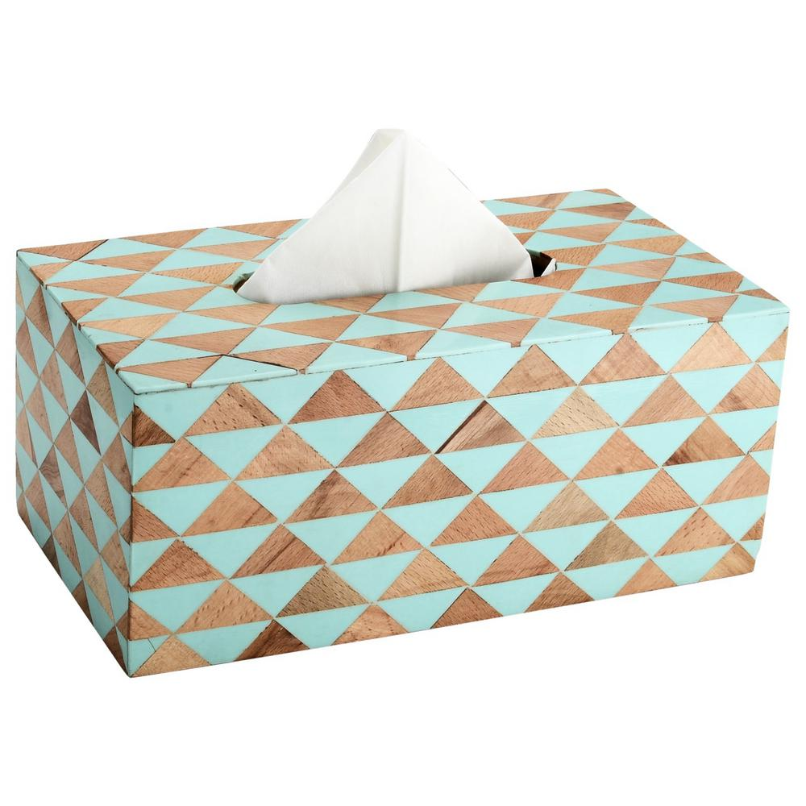
- 2 boxes of tissues 薄卫生面纸两盒

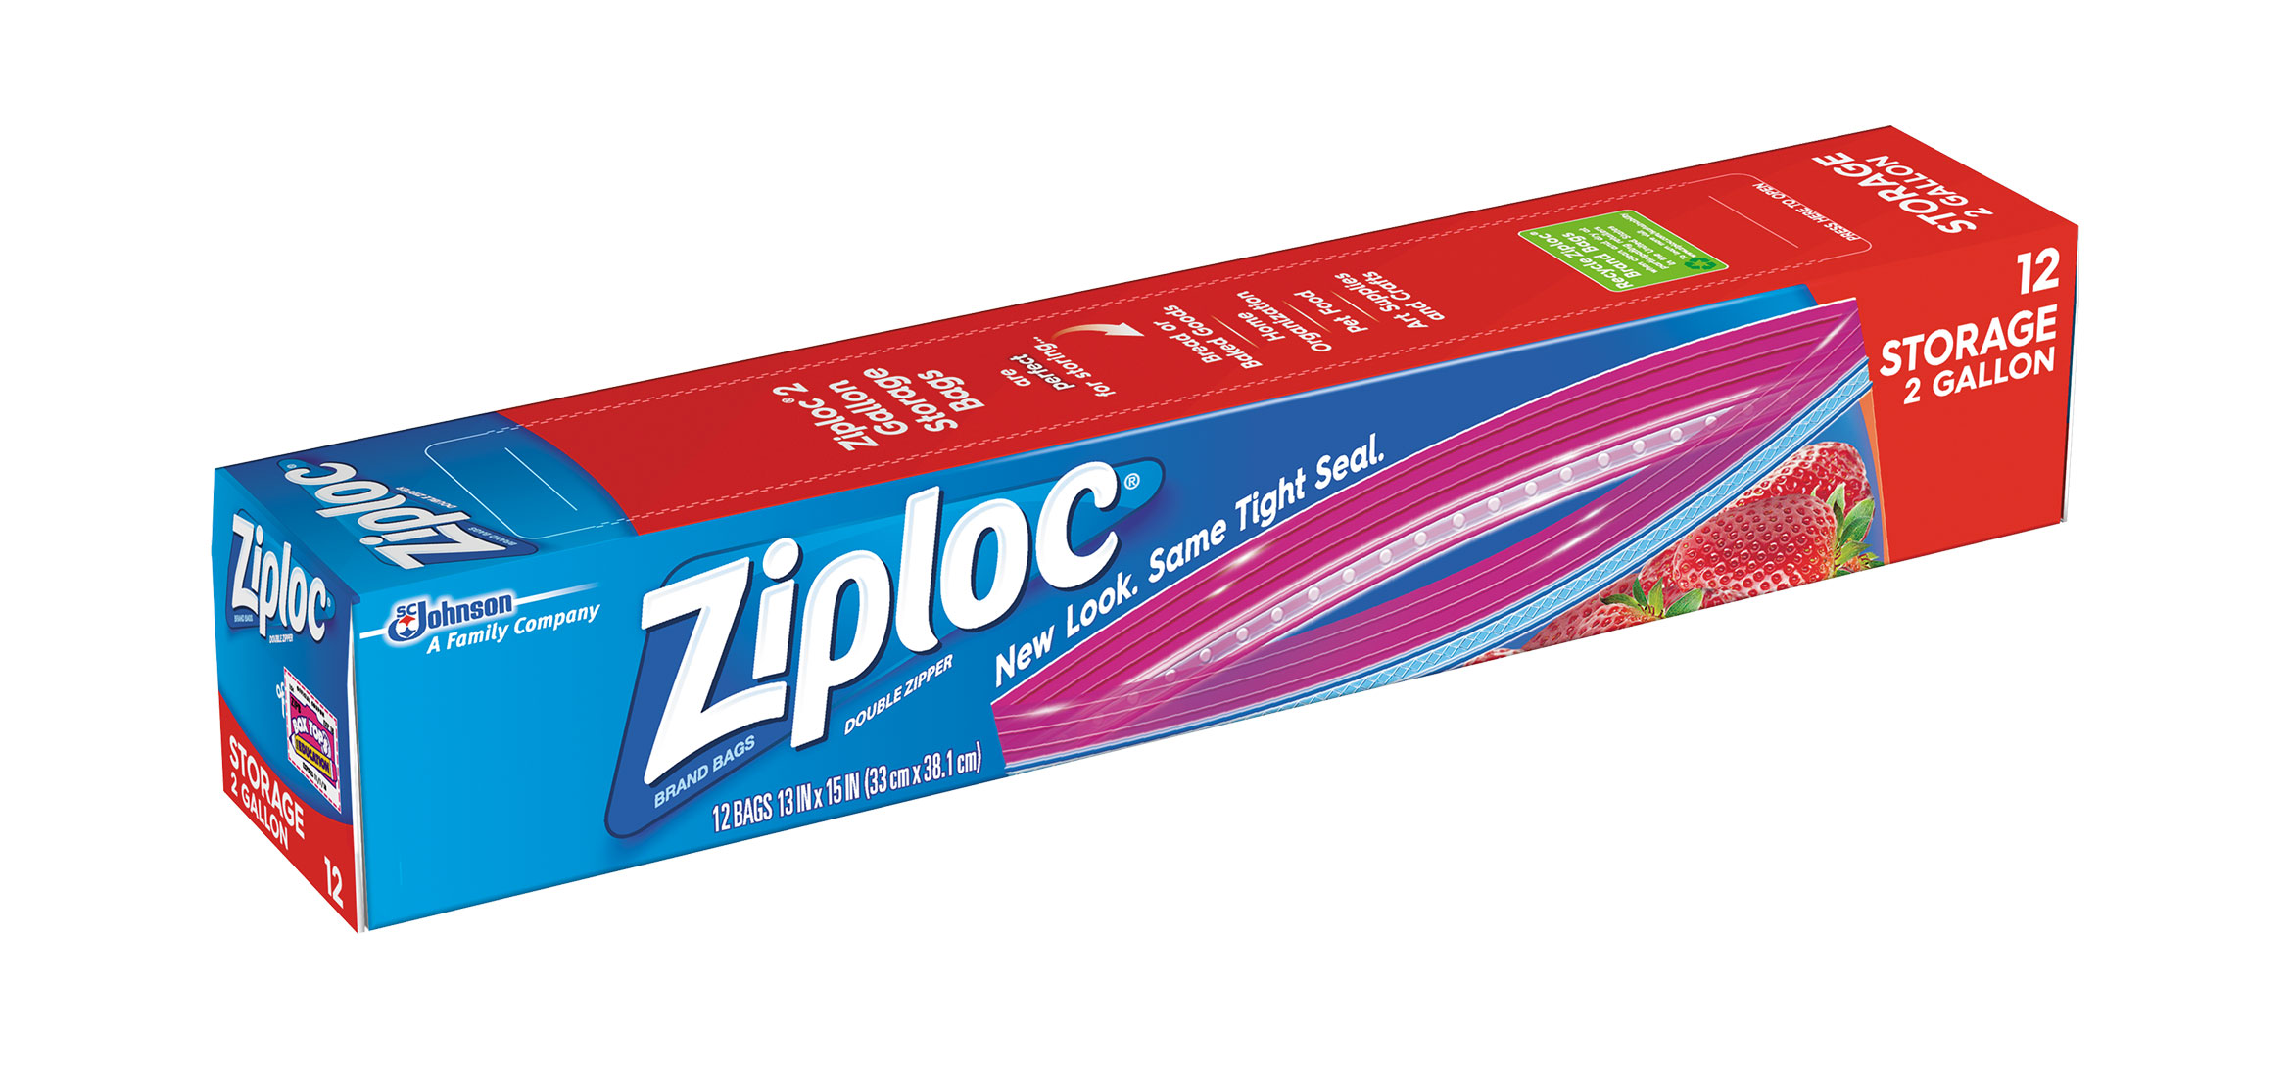
- 1 box of zip-loc baggies (2 gallon-sized)
密封塑胶袋一盒（1盒两加仑尺码）
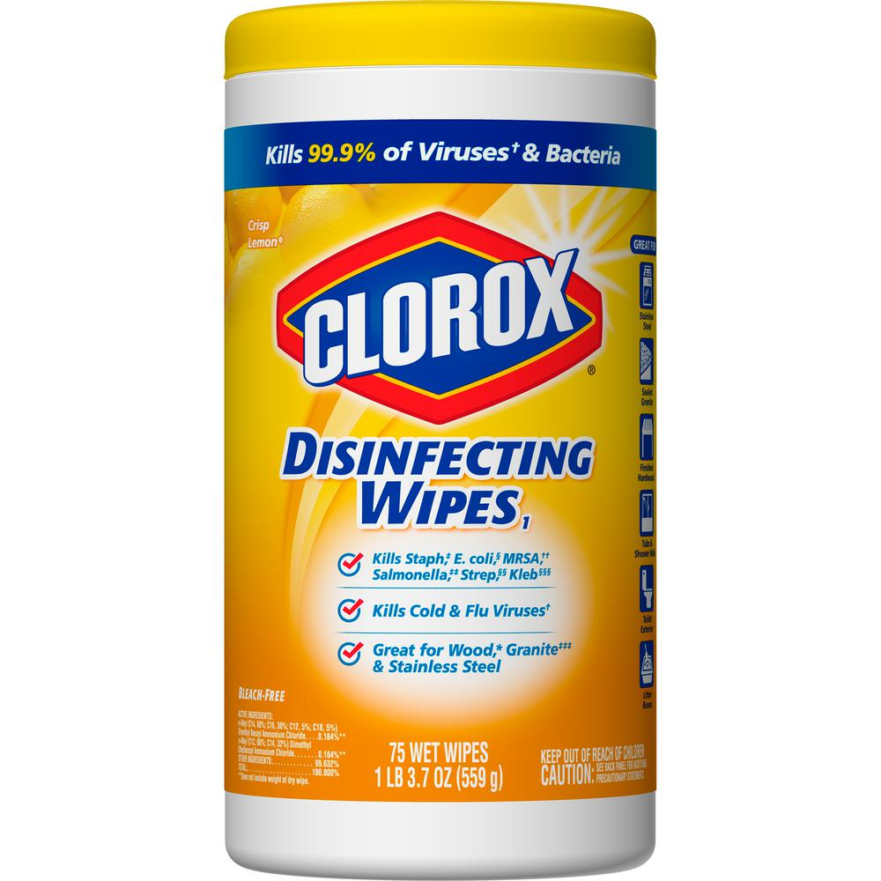
- 1 bottle of Clorox wipes 消毒湿纸巾一罐
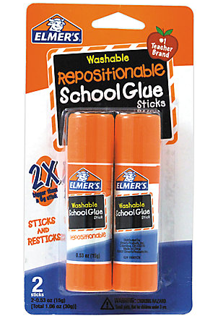
- 2 glue sticks 两条胶水棒

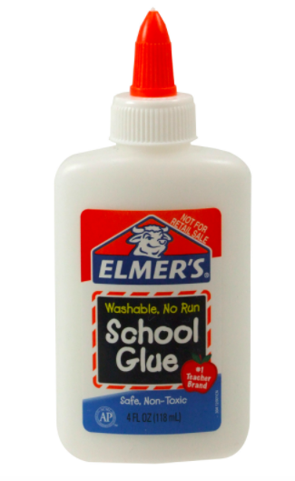
- 1 Elmer’s glue 一瓶胶水

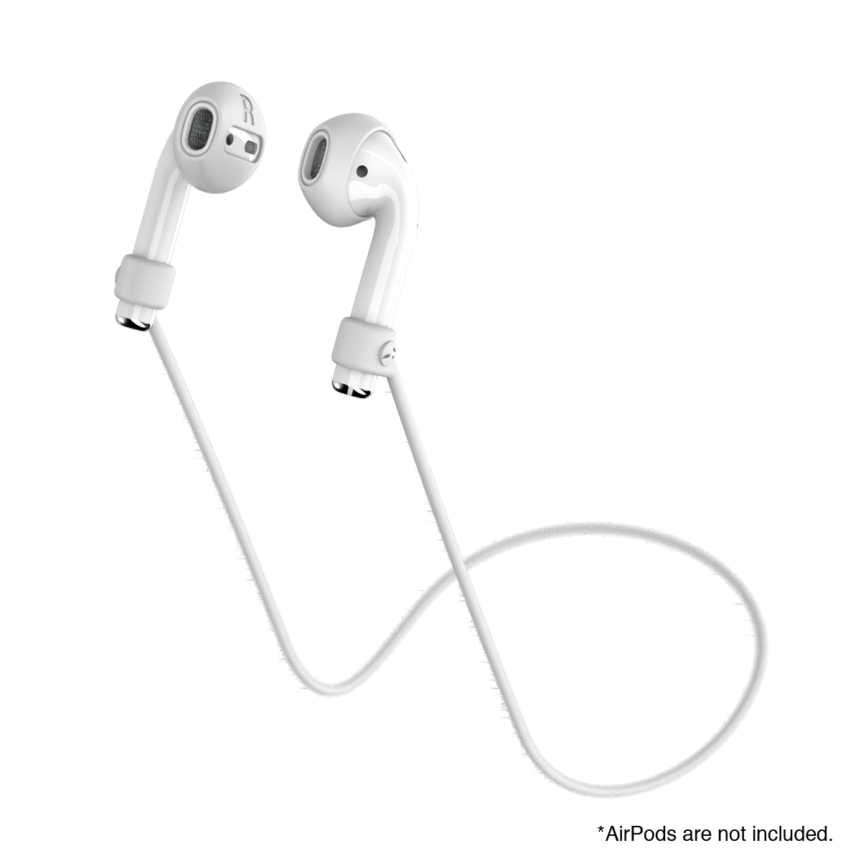
- 1 set of headphones 一对耳机

- 1 package of lined loose-leaf 一包活页纸

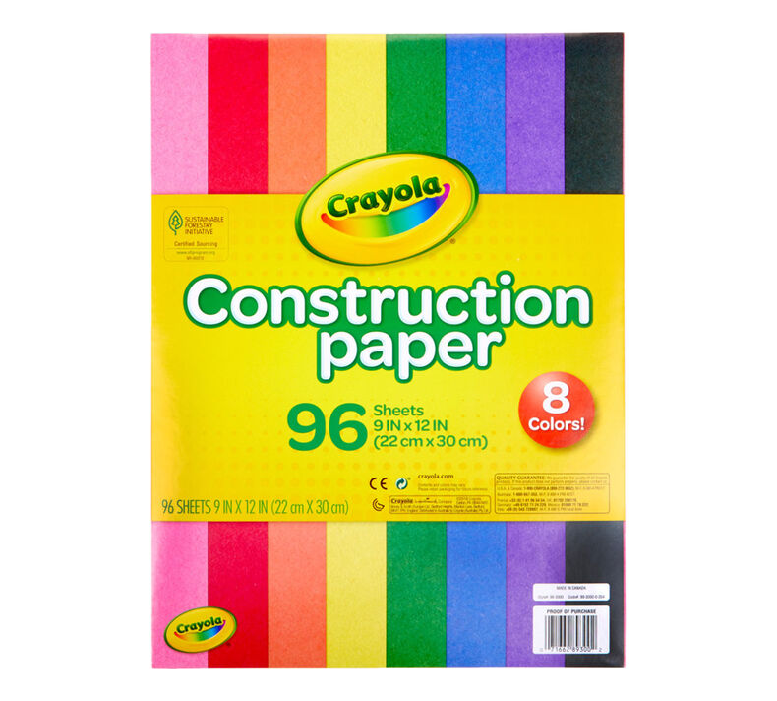
- 1 package of construction paper 一包 彩色图画用纸

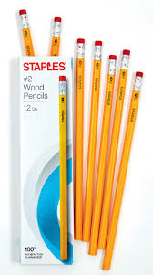
- 3 packs of pre-sharpened #2 pencils
3盒已经削好的2号铅笔
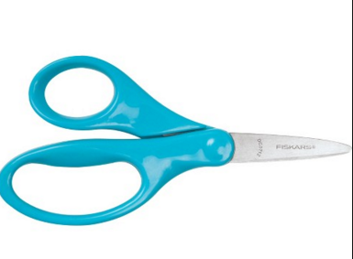
- 1 pair of Fiskar’s children’s scissors
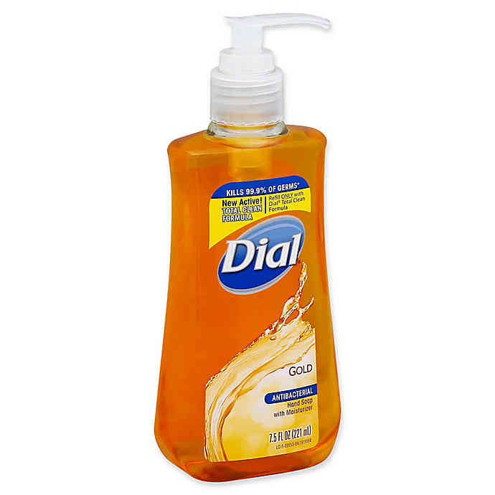
一把儿童用剪刀
- 1 bottle of hand soap 一瓶洗手液

Fifth Grade Supplies (Home): 以下是五年级需要的用品 (在家里的):
- 1 Marble Notebook (no spiral, one subject 70 pg.) 一本笔记本（不要卷轴, 大约70页）

- 1 pack of pencils 一盒铅笔

- 1 box of markers OR crayons OR colored pencils 一盒彩色水彩笔或者蜡笔或者彩色铅笔

Thank you for your support and cooperation!
感谢您的支持与合作！

Fifth Grade Teachers at PS 310
310 小学五年级老师 敬上

