Dear Parents,
In order to prepare for your child’s learning at home in the coming school year, please purchase the following supplies by September 9th, 2020. It is strongly recommended that you purchase the supplies from Staples to ensure high quality that will be durable throughout the year. Please purchase only the indicated quantity.

亲爱的家长们，
为了保证学生在新的学年顺利的进行远程学习，请为您的子女在2020年 9月9 日前购买下列文具用品。购买为确保高质量的文具将能在整个学年持久耐用，我们建议您从文具专卖店Staples 购买指定的数量的文具。

Fourth Grade Supplies: 以下是四年级需要购买的学习用品
- 12 plastic folders with pockets: (solid colors only-no designs or characters) 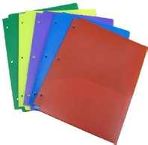(2 green, 2 red, 2 blue, 2 orange, 2 yellow, 2 black)
  - 两边有口袋的塑料文件夹（绿色，红色，蓝色，橙色，黄色，黑色各2个）
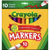
- 10 Marble Notebooks (no spiral, one subject 70 pg.) 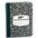 8本笔记本（不要卷轴, 大约70页）

- 1 box of skinny color markers (Crayola only) 细彩色水彩笔1盒 （Crayola牌子）
- 1 box of color pencil (Crayola only)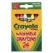彩色铅笔1盒（Crayola牌子）
- 1 box of watercolor paint 水彩颜料一盒 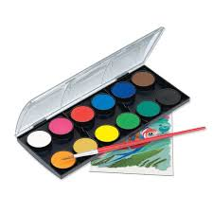

- 1 pack of Post-Its 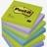 粘性便利贴1包
- 1 highlighter 荧光笔1只

- 1 stack of assorted-color construction paper 各种颜色的彩色手工纸1包
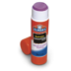
- 2 BIG glue sticks 大号胶棒1支
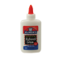

- 2 BIG glue bottles 大号液体胶水1瓶
- 1 green pen and 1 blue pen 1支蓝色圆珠笔, 1支绿色圆珠笔 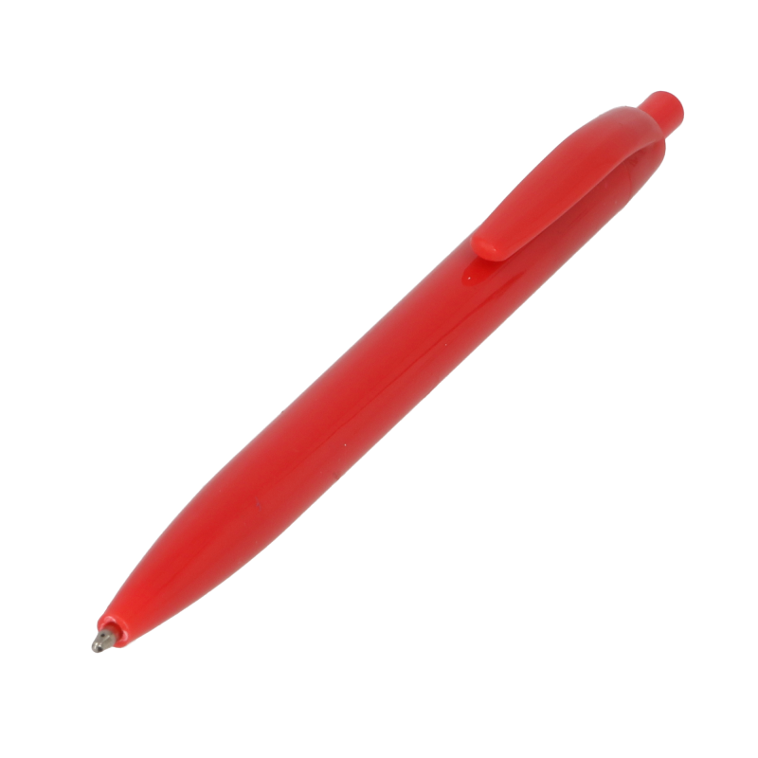
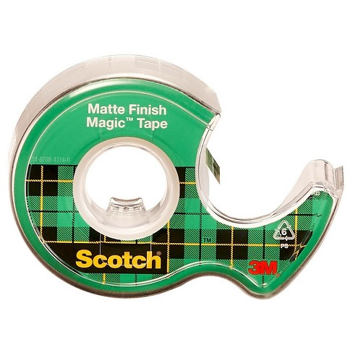

- 1 Scotch Tape 1卷透明胶带

- 1 ruler and 1 protractor 1把直尺 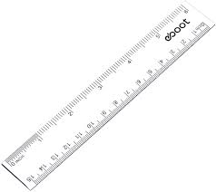 和一把三角尺 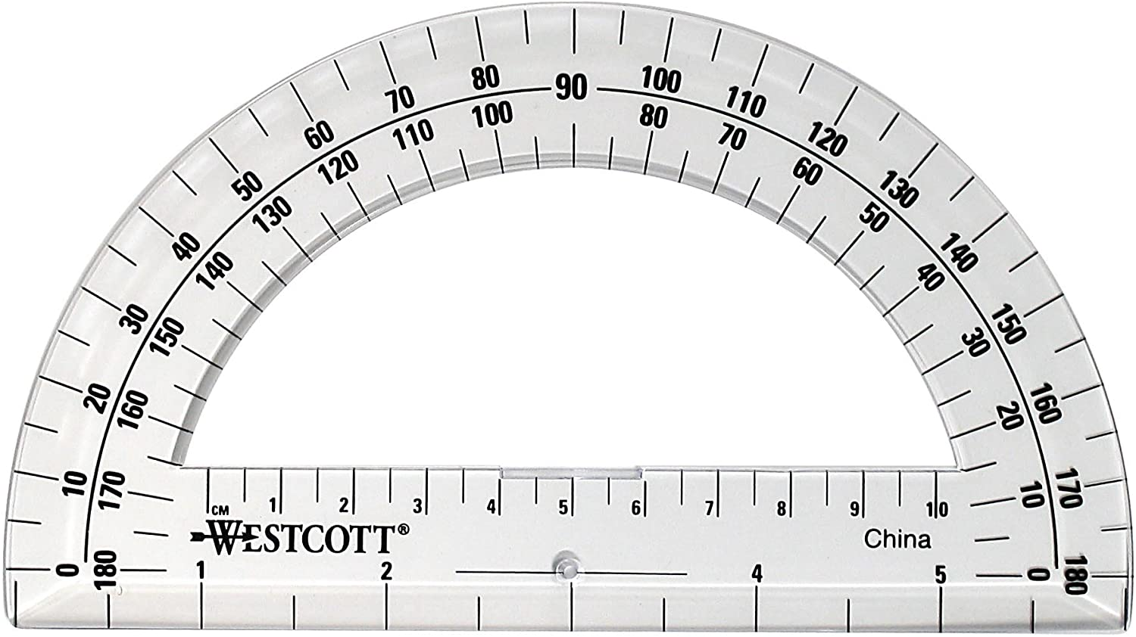

- A variety of paint brushes 多种型号画笔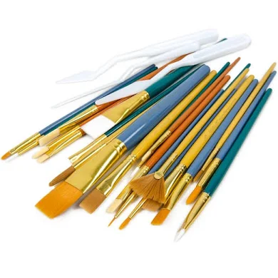

- A pair of scissors 一把剪刀

- Art materials such as pipe cleaners, buttons, pompoms, popsicle sticks 手工材料（毛根， 纽扣，毛球，冰糕棍）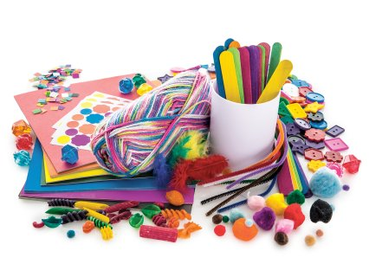

- Sharpie Markers 签字笔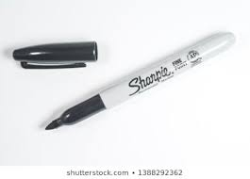
- Sketch book or drawing paper 速写本 或者 画画纸 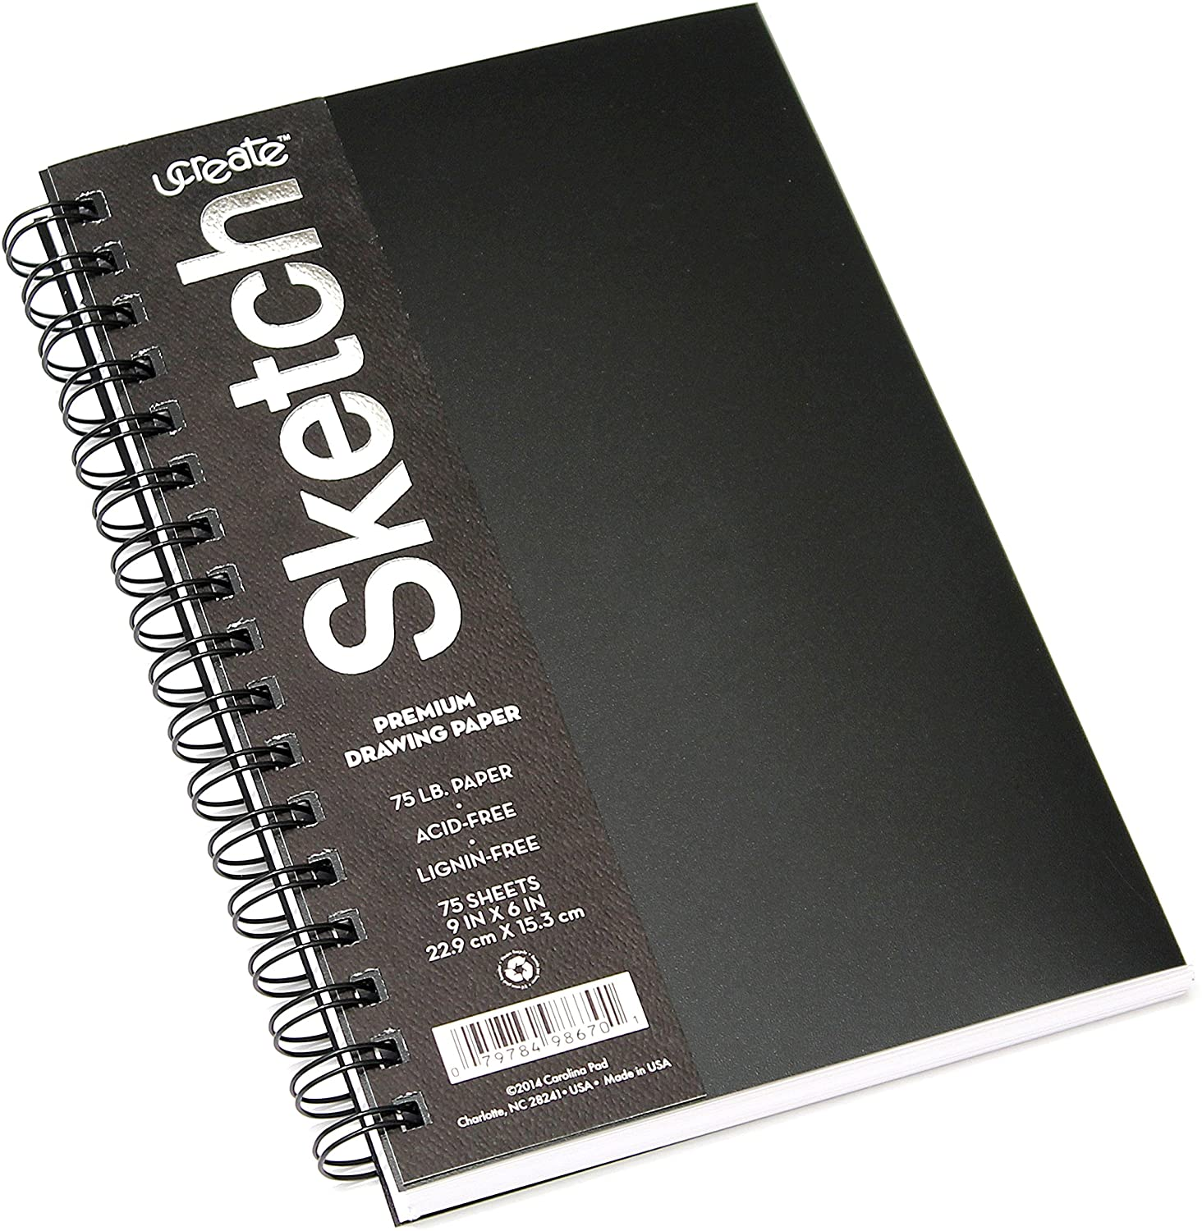 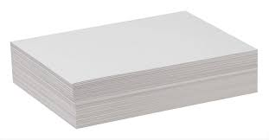

Thank you for your support and cooperation!
感谢您的支持与合作！
Fourth Grade Teachers at P.S.310
310小学四年级老师敬上

